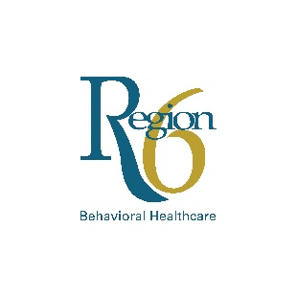
Region 6 Independent Living Classes And
Young People’s Peer Support Group Permission Slip

Please complete the permission slip to authorize the young adult under the age of 18 to attend and participate in independent living classes and peer support groups offered by Region 6. Cooking classes may be offered as an independent living class involving the use of cooking utensils and appliances with supervision.

I, , am the parent/legal guardian of and give my permission for him/her to attend independent living classes and/or the peer support groups offered by Region 6 Behavioral Healthcare.

I acknowledge and assume all risks associated with their participation in the independent living classes, including, without limitation, cuts, burns, food poisoning, slipping and falling, any other personal injury, and equipment and facility conditions. I have read and fully understand this waiver and in consideration of the acceptance of my entry, for myself and anyone legally acting on my behalf, I waive and release Region 6 Behavioral Healthcare and their subsidiaries and affiliates, and their respective officers, directors, shareholders, members, managers, employees and agents, and their respective successors and assigns, from any and all claims, liabilities or causes of action, including without limitation, death, bodily injury, property damage, or any other loss, damage or inconvenience whatsoever, arising from my participation in the classes.

By signing below, I authorize my child’s participation in:
All independent living classes and peer support groups
Only independent living classes
Only peer support groups

By checking this box, I authorize Region 6 to transport this youth to and from the TRY independent living classes when requested, including use of a third party transportation agency.

Emergency Contact Information:
Name:
Relationship:
Phone Number:
Address:

Signature Date
Please submit this permission slip
to the TRY Coordinator
(P) 402-996-8193 (F) 402-444-7722
khovorka@regionsix.com.

To register, contact
TRY Coordinator
3801 Harney Street Omaha NE 68131
(P) 402-996-8193 (F) 402-444-7722
nshanahan@regionsix.com
OR go online to wwww.regionsix.com

To register, contact
TRY Coordinator
3801 Harney Street Omaha NE 68131
(P) 402-996-8193 (F) 402-444-7722
nshanahan@regionsix.com
OR go online to wwww.regionsix.com

To register, contact
TRY Coordinator
3801 Harney Street Omaha NE 68131
(P) 402-996-8193 (F) 402-444-7722
nshanahan@regionsix.com
OR go online to wwww.regionsix.com

For additional information regarding the Independent Living Classes or the
Young People’s Peer Support Group, please visit www.regionsix.com.

