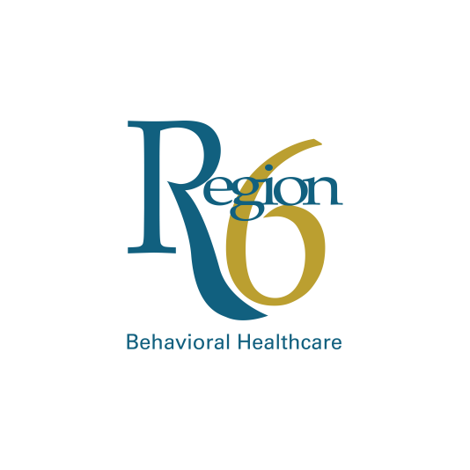

**Have you experienced a barrier when accessing children or youth mental health services?**

**We want to know!**

**Region 6 Behavioral Healthcare**

**System of Care - Barrier Submission Form**

***Please do not include Protected Health Information on this Form***

**Date: ____________________________________________**

**County of Residence: ________________________________**

**What type of services have you received for your child or as a youth for yourself (check all the apply):**

Service Coordination Probation

Mental Health Developmental Disabilities

Physical Health Juvenile Justice/Diversion

Education Counseling/Therapy

Other: __________________________________

**Description of Barrier:**

**Recommendations:**

***Email to: dbangert@regionsix.com***

**Thank you for sharing your voice and assisting us to make decisions to improve lives through Systems of Care!**