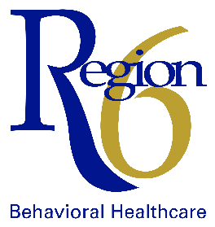
ANNUAL REPORT
Fiscal Year 2025
Contents
From the Board Chair 1
Structure and Governance 2
Who we Are 2
Strategic Priorities 3
Network Administration 4
Who We Serve 4
Fiscal Management 5
Network Provider Service Array 6
Network Service Outcomes 7
Community Initiatives and Coalitions 8
Community Initiatives 8
Grants 8
Consumer Affairs 8
Emergency Services Coordination 9
Housing Services Coordination 10
Prevention Services 11
Prevention Community Coalitions 11
The Stepping Up Initiative 12
Youth Services Coordination 13
Professional Partner Program 14

From the Board Chair
Dear Colleagues and Friends,
Region 6 Behavioral Healthcare is honored to provide high-quality behavioral health services to the residents of Cass, Dodge, Douglas, Sarpy, and Washington counties. Each year, we are grateful for the opportunity to support individuals, families, and communities on their paths toward wellness, recovery, and resiliency.
We extend our heartfelt appreciation to the Regional Governing Board, Behavioral Health Advisory Committee, Consumer Advisory Team, our communities, providers, coalitions, and dedicated staff. Your ongoing support and partnership make it possible for Region 6 to serve more than 7500 individuals across our five counties.
During fiscal year 2025 (FY25), Region 6 Behavioral Healthcare led a wide range of initiatives to promote mental wellness, support recovery, and reduce the impact of substance use disorders. We also made important progress in addressing opioid misuse through the coordination and distribution of opioid settlement dollars. These investments helped expand community-based prevention efforts, increase access to overdose-reversal tools, strengthen treatment and recovery supports, and enhance education about the risks associated with opioid use.
We are deeply grateful for our network of providers and prevention coalitions whose dedication ensures that individuals across our region receive the mental health and substance use prevention, treatment, and rehabilitation services they need. Together, we distributed more than 14,700 lethal-means prevention devices, an impact made possible by your compassion and unwavering commitment.
As we look ahead, Region 6 Behavioral Healthcare remains committed to leading with collaboration, innovation, and care. We look forward to strengthening our partnerships with the Regional Governing Board, Behavioral Health Advisory Committee, providers, coalitions, system experts, community partners, and above all, the individuals and families we are privileged to serve in Cass, Dodge, Douglas, Sarpy, and Washington counties.

Sincerely,
Mary Anne Borgeson
Regional Governing Board Chair

MISSION | To organize and provide an effective and efficient system of quality behavioral health services for the people of Cass, Dodge, Douglas, Sarpy, and Washington Counties.

Structure and Governance

Who we Are
Region 6 Behavioral Healthcare (Region 6/the Region) is one of six quasi-governmental regions established by the state of Nebraska in 1974 through the passage of LB 302, the Nebraska Comprehensive Community Mental Health Services Act, ensuring Nebraska residents with behavioral health disorders have statewide access to high-quality, cost-effective behavioral health services.
In 1977, LB 204 passed, extending the behavioral healthcare public policy to include substance use services. The Nebraska Behavioral Health Services Act, LB 1083, passed in 2004 and provided the framework and funds to develop community-based services so residents with behavioral health issues could be served within their communities.
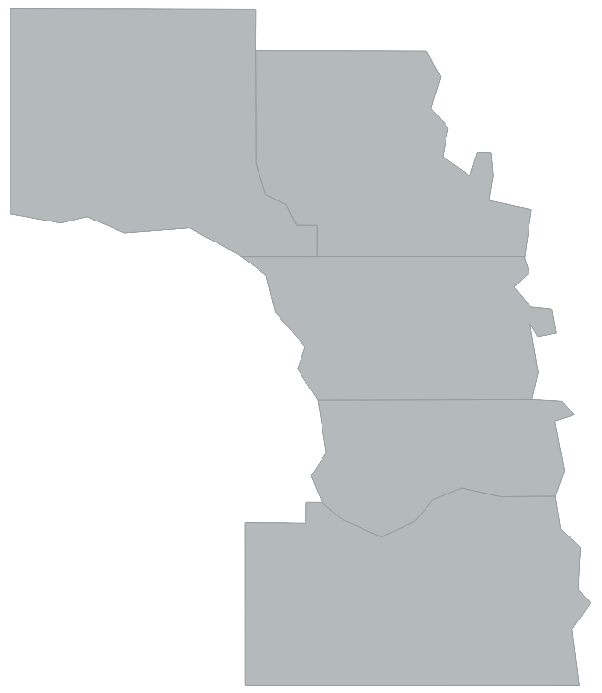
The regional system provides strategies for local participation and autonomy in the development
and delivery of behavioral health services. Region 6 Behavioral Healthcare’s success has been rooted in its ability to represent and respond to local needs. The Region’s efforts are further enhanced through the partnerships it has created with consumers, local service providers, the state of Nebraska, and other care systems.
Douglas
Dodge
Washington
Region 6 is responsible for evaluating, planning, developing, funding, and monitoring the publicly funded behavioral health system that serves residents of Cass, Dodge, Douglas, Sarpy, and Washington counties. This system includes mental health and substance use prevention, treatment, and rehabilitation services offered by a network of providers who are supported by federal, state, and county dollars.
Region 6 Behavioral Healthcare’s five (5) counties represent 2.66% of the total area of the state, the combined population of those five (5) counties represents approximately 43.83% of the total population of Nebraska.
- according to the U.S. Census 2020 data.
Cass
Sarpy

Statutory Responsibilities of Region 6 Behavioral Healthcare include:
- Administration and management of the Regional Behavioral Health Authority,
- Conducting audits of publicly funded behavioral health services,
- Evaluation and quality management,
- Initiation and oversight of contracts for the provision of publicly funded behavioral health services,
- Advocacy and involvement of persons served in all aspects of service planning and delivery,
- Fiscal management and accountability, including preparation of an annual budget and plan for the funding and administration of services, and
- Comprehensive planning, development, integration, and coordination of an array of publicly funded community-based behavioral health treatment and rehabilitation services for children and adults.

Regional Governing Board
The Regional Governing Board (RGB) is comprised of one County Commissioner or Supervisor from each of the five counties served by the Region. The RGB is responsible for the development and coordination of publicly funded behavioral health services in the Region.
Behavioral Health Advisory Committee
The Behavioral Health Advisory Committee (BHAC) advises the RGB on the planning, organization, contracting, and provision, evaluation, and fiscal analysis of the behavioral health services of the Region.
The RGB appoints members to the BHAC. Membership consideration includes residence within the region, direct and indirect behavioral health consumers, cultural diversity, and the community at large.
2025
Governing Board and Advisory Committee Members
Regional Governing Board | Representing | Behavioral Health Advisory Committee
Commissioner Taylor Boyle | Cass  County | Jeff Leach, Chair  Cameron Soester
Supervisor Pat Tawney, Vice Chair | Dodge  County | John Brady  Katlynn Osborn
Commissioner Mary Ann Borgeson, Chair | Douglas  County | Medjine Desgraves  Christopher Kelly
Commissioner Don Kelly | Sarpy  County | Julie Nielson  John Sheehan
Supervisor Lisa Kramer | Washington  County | Amy Zimmer, Vice Chair
 | Consumer Advisory  Team (CAT) | Michelle Gerdes
 | At Large | Michaelle Vega-Hernandez

Strategic Priorities
The FY25-FY26 Strategic Plan addresses changes in the behavioral health industry, stakeholder engagement, Region 6 visibility, and behavioral health conversations. Agency and department goals and workplans are developed in line with the Strategic Plan. All FY25-FY26 Strategic Plan goals and objectives are in process at the time of publication.
- Goal 1: | - Assess and adapt to behavioral health industry shifts at the federal, state, and local levels.
- Gather and analyze information related to industry changes.
- Identify the impact of industry shifts on Region 6.
- Develop and implement a plan to manage industry shifts impacting Region 6.
- Goal 2: | - Optimize stakeholder engagement.
- Build upon a culture of collaboration.
- Understand the values of a multi-generational workforce.
- Goal 3: | - Increase Region 6 visibility & promote conversations on behavioral health.
- Leverage social media to share behavioral health resources, increase awareness, provide data, and recruit staff.
- Increase behavioral health training opportunities provided to community members.

Network Administration
Region 6 Behavioral Healthcare functions as a vital safety net for residents across all ﬁve counties through a network of community service providers. These providers oﬀer a wide range of community-based, residential and non-residential services directly to consumers.
To qualify for Region 6-funded services, residents must meet ﬁnancial eligibility criteria, be uninsured, underinsured, or lack other means to pay for behavioral healthcare.

Who We Serve
The Region‘s Network of service providers offers an array of mental health (MH) and substance use disorder (SUD) services to area residents of all ages.
 |  | 12,027 Individuals Served  7,502 Treatment Encounters
Encounters by Race  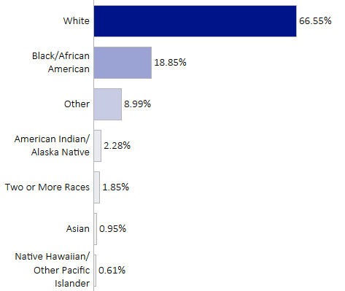 |  |  | Encounters by Age  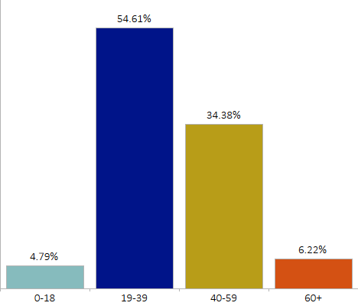
Encounters by Ethnicity  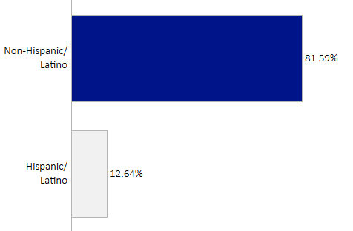 |  |  | Encounters by Gender  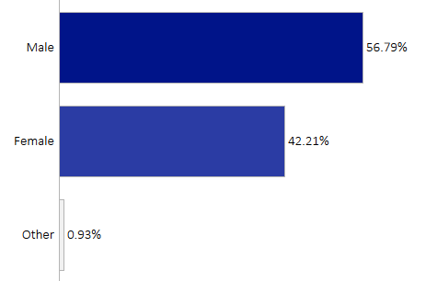
 | 21.01%  of encounters were reported to have a Serious Mental Illness or a Serious Emotional Disturbance during service provision |  |  |  | 56.99%  of encounters were reported to have a history of Trauma during service provision

Fiscal Management
Region 6 Behavioral Healthcare is committed to fiscal transparency, accountability, and effective use of resources. Region 6 receives state and federal funding through the Nebraska Department of Health and Human Services Divisions of Behavioral Health, Child and Family Services, and Public Health, as well as through each of the five (5) counties within the region.

FY23-25 Expenditures
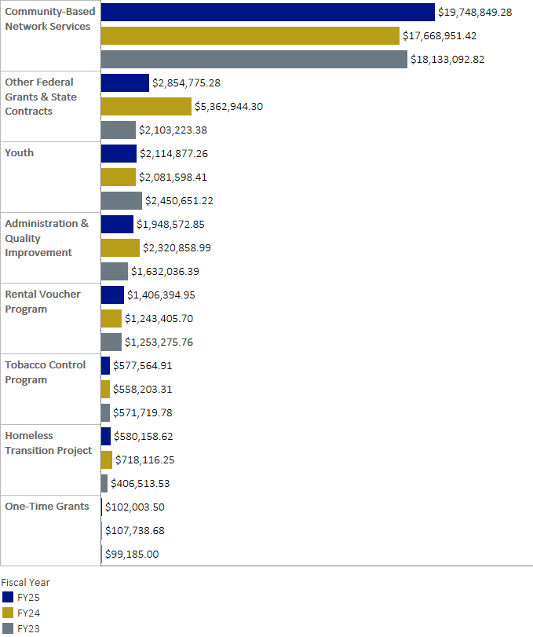

Network Provider Service Array
All services listed below address mental health unless otherwise noted.
Emergency | Inpatient |  |  | Non-Residential | Residential | Youth Non-Residential
A.R.C.H. Halfway House  www.archhalfwayhouse.org |  |  | Halfway House (SUD), Outpatient (SUD)
BAART Community Healthcare  www.baartprograms.com |  |  | Opioid Treatment (SUD)
Capstone Behavioral Health  www.capstonebehavioralhealth.com |  |  | Assessments (MH, Youth MH, & SUD), Outpatient (MH & Youth MH)
CenterPointe  www.centerpointe.org |  |  | Assessments (SUD), Community Support (SUD), Dual Disorder Residential (MH & SUD), Medication Management, Outpatient (SUD), Short-Term Residential (SUD)
Charles Drew Health Centers (CDHC)  www.charlesdrew.com |  |  | Assessments, Outpatient (MH & Youth MH)
CHI Health – Immanuel  www.chihealth.com |  |  | Acute Inpatient (Voluntary MH & Involuntary MH), Assessments (MH & SUD), Emergency Protective Custody, Medication Management, Outpatient (MH, Youth MH, & SUD)
CHI Health - Lasting Hope Recovery Center  www.chihealth.com |  |  | Acute Inpatient (Voluntary MH & Involuntary MH), Emergency Protective Custody, Sub-Acute Inpatient
Community Alliance  www.community-alliance.org |  |  | Assertive Community Treatment, Assessments (MH & SUD), Community Support, Coordinated Specialty Care, Day Rehabilitation, Hospital Diversion, Intensive Community Services, Intermediate Residential, Medication Management, Outpatient (MH & SUD), Psychiatric Residential Rehabilitation, Recovery Support, SOAR, Supported Employment
Douglas County Community Mental Health Center  www.cmhc.douglascounty-ne.gov |  |  | Acute Inpatient (Voluntary MH & Involuntary MH), Assessments (MH & SUD), Day Treatment, Emergency Community Support, Emergency Protective Custody, Intensive Outpatient (SUD only), Medication Management, Outpatient, Social Detoxification (SUD)
East Central District Health Department  www.ecdhd.ne.gov |  |  | Assessments, Medication Management, Outpatient (MH & SUD)
Heartland Family Service  www.heartlandfamilyservice.org |  |  | Assessments (MH & SUD), Crisis Response (MH & Youth MH), Crisis Stabilization, Emergency Community Support, Medication Management (MH & Youth MH), Outpatient (MH, Youth MH, Youth MH JJC, & SUD), Recovery Support (MH & SUD)
Integrated Behavioral Health Services  www.ibhealthservices.com |  |  | Secure Residential
Lutheran Family Services  www.onelfs.org |  |  | Assessments (MH & SUD), Community Support, Crisis Response (MH & Youth MH), Intensive Outpatient (SUD only), Medication Management, Outpatient (MH, Youth MH, SUD, & Youth SUD), Recovery Support (MH & SUD)
Methodist Fremont Health  www.bestcare.org |  |  | Acute Inpatient (Involuntary MH)
The Nebraska Medical Center  www.nebraskamed.com |  |  | Emergency Psychiatric Observation
Nebraska Urban Indian Health Coalition  www.nuihc.com |  |  | Assessments (SUD)
NOVA Treatment Community  www.novatc.org |  |  | Short-Term Residential (SUD), Therapeutic Community (SUD)
OneWorld Community Health Centers  www.oneworldomaha.org |  |  | Assessments (MH & SUD), Medication Management, Outpatient (MH & SUD) Client Assistance Program (MH & SUD)
Region 6 Behavioral Healthcare  www.regionsix.com |  |  | Professional Partner Program, Transition-Age Youth Rental Assistance Program, Rental Assistance Program
The Salvation Army  www.centralusa.salvationarmy.org/omaha |  |  | Emergency Community Support, Intensive Community Services, Mental Health Respite
Santa Monica  www.santamonicahouse.org |  |  | Assessments (SUD), Halfway House (SUD), Intermediate Residential (SUD), Recovery Support (SUD)
Telecare Corporation  www.telecarecorp.com |  |  | Secure Residential

Network Service Outcomes
Region 6 is dedicated to empowering consumers, enhancing wellbeing, and supporting recovery and self-suﬃciency through a comprehensive and responsive service network. The Region utilizes Service Outcomes to monitor the quality of services. These outcomes are measured using data pulled from the Centralized Data System (CDS), as well as survey data submitted by network providers.
Key outcomes from FY25 reﬂect positive consumer experiences and successful service delivery. Measurable improvements in mental health, accessibility, and quality of life demonstrate the Region’s ongoing commitment to high-quality, eﬀective services that address the diverse needs of the community.
87.7% | of encounters admitted into a service within the service-speciﬁc timeframe.
72.7% | of encounters discharged from services to stable living.
8.2% | of encounters discharged from a service without notice or stated discharge reason.
26.4% | of encounters re-entered into the same service within a 30-day interval.

Consumer Surveys
Consumers are invited to participate in satisfaction surveys to share their perceptions of service quality. These surveys use a 5-Point Likert Scale to measure the consumer’s satisfaction with timeliness of services, improvement in functioning, satisfaction with services, and improvement in dealing with crises.
Fiscal Year 2025 survey results indicate consumers felt services met or exceeded expectations in accessibility, eﬀectiveness, and care quality. The feedback underscores the success of Region 6 programs in delivering responsive and eﬀective care.
98.8% | of encounters reported satisfaction with services.
98.9% | of encounters reported timely access to services.
96.4% | of encounters reported improvement in functioning or a reduction in symptomology as a result of services.
90.5% | of encounters reported improvement in dealing with crisis as a result of services.

Community Initiatives and Coalitions

Community Initiatives
In addition to providing mental health and substance use disorder services provided through the provider network, Region 6 initiates and participates in various mental health and substance use disorder community initiatives throughout the fiscal year. These initiatives address community-specific behavioral health needs.

Grants
Region 6 Behavioral Healthcare receives federal grant funds for specific, targeted projects. Below are some of FY25’s grant-funded initiatives.

American Rescue Plan Act (ARPA)
Region 6 received American Rescue Plan Act (ARPA) and supplemental block grant dollars in both substance use and mental health to develop and enhance several initiatives.
The Nebraska Legislature enacted LB1412 which included a provision to allocate federal ARPA funds for a pilot program aimed at gun violence and Post Traumatic Stress Disorder (PTSD). A Request for Letters (RFL) was issued, and the contract was awarded to OMNI Inventive Care to carry out the study and various related activities.

Crisis Counseling Program
Following the tornado and storm damage to areas in western Douglas and southern Washington Counties in April 2024, the state of Nebraska was awarded a federally funded Crisis Counseling Program grant. The two-phase process began in May 2024 and ended in May 2025, allowing for numerous activities to provide assistance to 413 local residents.

System of Care Grant
In FY25, Region 6 Behavioral Healthcare concluded the Comprehensive Community Mental Health Services for Children with Serious Emotional Disturbances grant awarded by the Substance Abuse and Mental Health Services Administration (SAMHSA) effective August 31, 2021- August 30, 2025. The grant supported school-based mental health services in eight school districts across Cass and Washington Counties, along with parent peer mentoring and training in children’s mental health and evidence-based practices. Grant partners included Educational Service Unit #3, the Lead Family Coordinator, Project Harmony, and the University of Nebraska Public Policy Center. Over the four-year grant period, 425 students received one-on-one school-based therapeutic services, exceeding the goal of 412 students; 88 unduplicated families received parent peer mentoring; and 2,255 unique individuals participated in 145 trainings related to children’s mental health, significantly surpassing the original participation goal of 425 individuals.

Consumer Affairs
The Regional Consumer Specialist (RCS) at Region 6 Behavioral Healthcare is an individual with lived-experience (personal and/or from a family perspective) in mental health and substance use disorders. The RCS is a Certified Peer Support Specialist (CPSS) who uses their experience to provide support to individuals served by Region 6 as well as other CPSSs in the community. Key duties of the position include offering educational opportunities for peers and professionals; providing technical assistance for peer and recovery support services; building relationships in the community; and leading efforts to break the stigma surrounding mental health and substance use disorders through the sharing of recovery journeys.
In FY25, the Regional Consumer Specialist played a large role in organizing and executing the second Annual Region 6 Peer Summit: Sustaining the Self Ethics and Self Care of Peer Specialists. The RCS also facilitated Wellness Recovery Action Plan (WRAP) I and II trainings, while building capacity for additional instructors in the curriculum. Community outreach efforts included the American Foundation for Suicide Prevention (AFSP) Out of the Darkness Walk resource booth, Mental Illness Awareness Week, and the NAMI Omaha community walk. The Regional Consumer Specialist also had many opportunities to share their personal recovery journey, provide advocacy for lived experience, and support and assist individuals experiencing mental health challenges and their loved ones.

Emergency Services Coordination
Region 6 Behavioral Healthcare’s Emergency Services Coordination provides oversight, planning, data analysis, and coordination of the emergency behavioral health system in the five-county area. The Senior Manager of System Coordination and Manager of Emergency Services work with area emergency departments, hospitals, first responders (including law enforcement), county attorneys, crisis response and detoxification programs, jails, and other emergency stakeholders to ensure that consumers have timely access and quality care during a behavioral health crisis.
The Senior Manager of System Coordination facilitates quarterly meetings with emergency system stakeholder representatives from the five counties, as well as addresses systems issues and needs that are unique to each county. Monthly data reports are collected from the various stakeholders to allow Region 6 to review hospital capacity, crisis response utilization, crisis stabilization, psychiatric emergency services usage, emergency protective custody and Board of Mental Health data, and detoxification data. The Manager of Emergency Services also reviews Board of Mental Health referrals from area hospitals to the Lincoln Regional Center (LRC) and works with consumers and staff at LRC to address discharge planning.

Community Behavioral Health Clinics (CCBHCs)
Region 6 coordinated with the three area CCBHCs to issue a Request for Letters to provide funding. All three CCBHCs submitted applications and were awarded funds to assist with start-up costs. CCBHCs are community-based providers designed to deliver comprehensive mental health and substance use services regardless of a person’s ability to pay. They provide a full range of services, including crisis response, outpatient mental health and addiction treatment, care coordination, and connections to primary care and social supports. CCBHCs are required to serve anyone who seeks help and emphasize timely access, integrated care, and coordination with hospitals, law enforcement, and other community partners. The model is funded to improve access, quality, and outcomes in behavioral health care in the Region.

Crisis Stabilization
Region 6 partnered with Sarpy County leadership to develop a Crisis Stabilization program that will serve each of the Region’s five counties. Region 6 has contracted with Heartland Family Service (HFS), who began serving consumers in the program in August 2024.
Currently, the Crisis Center provides services for adults who are experiencing a behavioral health crisis and are voluntarily agreeing to receive treatment at their program. Consumers can stay for up to 24 hours, during which they are assessed for safety and needs, provided with crisis counseling in a therapeutic environment, and with referrals to resources and programs within the community. Consumers may also receive up to 90 days of case management post discharge.
In 2025, HFS began remodeling their Sarpy facility with an estimated completion date in early 2026. Once the work has been completed, the program will have 12 beds in which consumers can stay for several days to continue their stabilization before returning to the community. The program’s Mental Health Respite service allows consumers to stay for up to 30 additional days to further stabilize and/or secure a safe environment to reside post discharge, if needed.

Emergency Community Support
Emergency Community Support (ECS) provides 90 days of case management for consumers experiencing a behavioral health crisis. ECS staff can support consumers to ensure that they are scheduling and attending appointments, obtaining and taking medications and refills as prescribed, and obtaining and sustaining housing and employment. ECS staff may provide consumers with referrals to community programs, assist consumers in completing forms to obtain Social Security and/or Medicaid benefits, and connect consumers to community resources.
Region 6 participated in discussions with local emergency departments (EDs) and conducted a needs assessment, identifying Emergency Community Support services as a way to address unnecessary utilization of EDs for behavioral health issues. To meet this need, Region 6 contracted with Community Alliance to provide Emergency Community Support services to the Region.

Mental Health Intermediate Residential Program
The Community Alliance Mental Health Intermediate Residential program is a longer-term program for consumers who often have histories of extensive use of hospitals or residential programs and need more gradual and intentional treatment before exploring living independently in the community. This program operated for a full year and reached capacity in FY25.

Plans for One (PF1)
Plans for One provide individualized, person-centered treatment and rehabilitation services for consumers discharging from, or at risk of a return to, the Lincoln Regional Center. PF1 serves individuals who may benefit from a level of supervision and structure that exceeds what can typically be provided by traditional network-funded services. The Region initiated eight Plans for One for four unique consumers in FY25. Two consumers were able to successfully transition into lower-level community services without additional services or inpatient hospitalizations.

Housing Services Coordination
Housing services at Region 6 provide rental assistance to individuals with extremely low income who are recovering from a serious mental illness and/or substance use disorder. The Regional Rental Assistance Program (RRAP) serves individuals aged 19 and up, while the Transition Age Youth Rental Assistance Program (TAYRAP) serves individuals aged 18-26 years. These programs function much like the federal Housing Choice Voucher Program operated by public housing authorities (also known as Section 8).

Regional Rental Assistance Program (RRAP)
RRAP provides access to decent, safe, and affordable housing to support individuals on their journey to recovery. Rental assistance and (in some cases) assistance with security or utility deposits is provided to eligible participants of the Region 6 area.

Transition Age Youth Rental Assistance Program (TAYRAP)
TAYRAP assists young adults with independent living and the transition from youth into adulthood. The program is designed to provide the youth with a smooth transition into independent living by gaining the skills necessary to live independently. TAYRAP housing assistance is a temporary subsidy and ends prior to the youth reaching the age of 26.

Prevention Services
Prevention is an important component of the behavioral healthcare continuum of care. The prevention team at Region 6 provides assessment, coordination, planning, and implementation of substance use prevention, mental health promotion, and suicide prevention activities and training.

Mental Health First Aid
Region 6’s Mental Health First Aid (MHFA) Initiative was successful in expanding adult and youth training, reaching 782 participants in FY25. MHFA Instructor capacity was built through the support of training costs for onboarding at First National Bank of Omaha, Girls Scouts, Three Rivers Health Department, and independent community instructors.

NEOne
Region 6’s Prevention team launched NEOne, a Social Connectedness Movement promoting the building of better-connected communities across the Region. This effort encourages individuals and organizations to pledge to improve their social connection opportunities and build their understanding of mental wellbeing. NEOne highlights current resources and community partners impacting six key transition points across the lifespan.

Opioid Response
Narcan, an opioid overdose reversal drug, was disseminated at no cost to individuals through local pharmacies in partnership with the Nebraska Pharmacists Association. Forty-two (42) pharmacy locations in the Region 6 area participated in the initiative and can be found at www.stopodne.org.

Safety & Risk Reduction
Region 6 disseminated 7,658 medication lock boxes, 6,450 Deterra medication disposal pouches, and 625 firearm trigger locks to individuals and organizations across the service area, for a total of 14,733 risk reduction and safety devices distributed across communities to reduce risk of accidental injury, overdose and suicide.

Suicide Prevention
Region 6 partnered with the Nebraska Suicide Prevention Coalition on the CDC Suicide Prevention Grant targeting men ages 25-64. Strategies included QPR suicide prevention training, Counseling on Access to Lethal Means (CALM) training, distribution of firearm trigger locks, hosting resource booths at community events, and presentations for professional schools, local unions and trade organizations.

Prevention Community Coalitions

Coalition Rx
Coalition Rx completed 10 full implementation rounds of the Too Good for Drugs and Violence curriculum reaching a total of 1,131 youth. The partner locations included Charles B. Washington Library, Lewis and Clark Middle School, Sherman Elementary, Lothrop Elementary, Norris Elementary, Salvation Army in Douglas County and Care Core Life House and ASPIRE for Greatness in Dodge County.

Metro Omaha Tobacco Action Coalition
Metro Omaha Tobacco Action Coalition (MOTAC) worked with media contractor Emspace+Lovgren to create five short interview-style videos. Three of the videos discuss the benefits of smoke-free multiunit housing with representatives from the Metro Omaha Property Owners Association (MOPOA), Omaha Fire Department, and Restoring Dignity. Two videos feature representatives from CenterPointe and Community Alliance, discussing the importance of incorporating tobacco/nicotine cessation in behavioral health treatment.

Project Extra Mile
Project Extra Mile coordinated two alcohol retail compliance checks in FY25. The first check resulted in 23 (9%) of 249 businesses selling alcohol to the minor, and the second resulted in 25 (8%) of 307 businesses being cited for selling alcohol to the minors.

The Stepping Up Initiative
The Stepping Up Initiative is a national, data-driven framework launched in 2015 to reduce the over-incarceration of people with mental illness in local jails. It supports counties in using evidence-based practices to reduce bookings, shorten lengths of stay, improve connections to care before release, and decrease jail involvement for individuals with serious mental illness. Participating counties commit to collecting and using data to understand mental health prevalence in jails, implement effective strategies, and track progress. The initiative urges county leaders to review current practices and to adopt policies, programs, and practices that impact the following 4 key measures.
- Reduce the number of people with a serious mental illness in jail.
- Shorten the average length of stay for people with a serious mental illness in jail.
- Increase the percentage of connections to care for people with a serious mental illness in jail.
- Lower rates of recidivism for individuals with a serious mental illness in jail.

Information Sharing Project
In summer 2022, stakeholders from the criminal justice and behavioral health systems in Douglas and Sarpy counties took part in a Sequential Intercept Model (SIM) mapping exercise led by Policy Research Associates. This SIM mapping exercise identified improved information sharing as a top priority, prompting the Region to begin planning a collaborative solution with criminal justice partners.
Region 6, in partnership with criminal justice system stakeholders including law enforcement and corrections, entered into an agreement with Netsmart for consultative and implementation services in December 2024. These services included a comprehensive assessment of existing data sources used by partners and a proof-of-concept demonstration of Netsmart’s CareManager software. Region 6 and project partners are currently reviewing the assessment findings and exploring options to determine next steps.

Frequently Used Systems Engagement
FUSE is a nationally recognized model implemented across the country that uses data to identify high utilizers of public systems for targeted housing interventions. In collaboration with the Corporation for Supportive Housing (CSH), Omaha will implement the FUSE framework by leveraging data from three key systems: homelessness/unsheltered services, healthcare, and corrections. This data will allow the Region to identify individuals with the highest system utilization and prioritize housing support for those individuals. Region 6 is an active participant in this project.

Section 5121 of the Consolidated Appropriations Act (CAA)
Stepping Up will continue to facilitate and coordinate discussions with jails and managed care organizations regarding Section 5121 of the CAA. This provision authorizes Medicaid coverage for certain pre-release and transitional services designed to support young adults as they move from incarceration back into the community. These services may include care coordination, behavioral health supports, and connections to community-based providers, with the goal of improving continuity of care, reducing recidivism, and promoting successful community reintegration.

Youth Services Coordination
Region 6 Behavioral Healthcare is committed to coordinating and enhancing the behavioral health system for youth and young adults. This work includes identifying service gaps, assessing needs, and expanding community-based services to respond to emerging community needs. Region 6 also provides oversight of youth-funded service providers to ensure the delivery of high-quality care while fostering collaboration across multiple systems to ensure a coordinated approach to address the behavioral health needs for youth across our services area.
During FY25, Youth Services Coordination actively engaged in multiple community initiatives focused on strengthening youth mental health supports and leadership across the region, including serving on the Steering Committee for the 2025 Nebraska School Mental Health Conference. The conference brought together nearly 350 educators, mental health professionals, and advocates from across the state to receive expert-led training, innovative resources, and practical strategies to strengthen mental health services in schools. Region 6 also served on the planning committee for the Youth EmPOWER Summit, the third annual event that brought together 540 students from 37 area high schools to promote youth leadership development and mental health advocacy.
Another key focus area in FY25 was the expansion of school-based suicide prevention efforts. After extensive research, Region 6 selected Sources of Strength as the evidence-based, peer-to-peer school program to support. Staff conducted outreach and recruitment to identify interested schools and provided funding opportunities to assist with start-up and implementation costs.

Professional Partner Program
The Professional Partner Program (PPP/PP Program) provides strength-based and family-driven behavioral health coordination, utilizing the Wraparound Model for children, young adults, and their families. The program is designed to help families achieve stability, improve functioning, and get families in touch with community-based resources and services to improve family outcomes.

Who We Serve
The Professional Partner Program served a total of 294 consumers within Cass, Dodge, Douglas, Sarpy, and Washington counties in FY25. Below are the demographics of those individuals served.
Individuals Served |  |  | Individuals Served by County of Residence
294 |  |  | 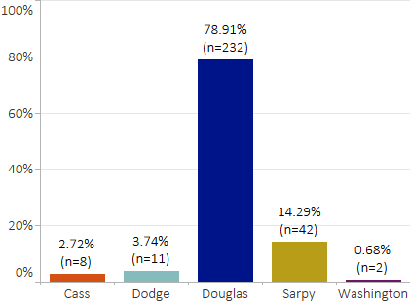
Demographics
Age | 3-6  Years | 1.70%
Age | 6-12  Years | 38.78%
Age | 13-18  Years | 53.74%
Age | 19-26  Years | 6.46%
Gender | Male | 58.16% | Individuals Served by Diagnosis*
Gender | Female | 40.82% | 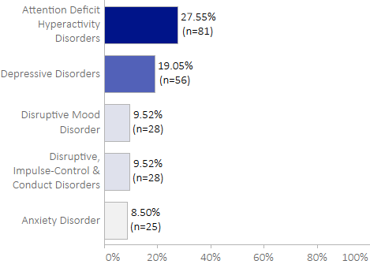
Race | White/Caucasian | 59.18%
Race | Black/African American | 28.91%
Race | Asian | 5.78%
Race | American Indian/ Alaska Native | 4.42%
Ethnicity | Non-Hispanic/Latino | 70.41%
Ethnicity | Hispanic/Latino | 29.59%
*Top five primary diagnoses of individuals served in FY25.

Program Outcomes
Professional Partners (PPs) provide behavioral health coordination services to assist families in developing lasting and eﬀective support networks to meet their mental health needs. The Program’s success is measured with program outcomes. Below is a snapshot of the outcomes designed for the Professional Partner Program.
Successful Discharges | CAFAS Score Reduction | Remained in Home
46.63% | 70.30% | 91.05%
of individuals successfully discharged in FY25 after 6+ months of enrollment in PP Program services. | of individuals showed clinically significant CAFAS score reduction after 6+ months of enrollment in PP Program services. | of caregivers reported no out of home placements following discharge from the PP Program.
Timely Access | Needs Met | Satisfaction
96.67% | 86.67% | 93.33%
of families reported experiencing timely access to enrollment into the PP Program. | of families reported their needs were met through the PP Program services. | of families reported overall satisfaction with PP Program services received.

Region 6 Behavioral Healthcare
4715 South 132nd Street | Omaha, Nebraska 68137
www.regionsix.com

Working Together for a Healthy Nebraska

